# Appendices

## Appendix 1: The fitted and simulated results of the inflation and one-year risk free rate.

*Appendix 1A: Log-normal distribution fitted to historical inflation rate*

*Appendix 1B: Log-normal distribution fitted historical to one-year risk free rate*

*Appendix 1C: Header of 130 years * 100 simulations on inflation rate according to log-normal*

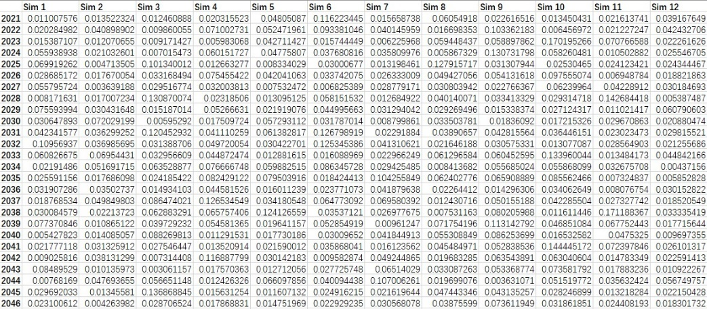

*Appendix 1D: Header of 130 years * 100 simulations on one year risk free rate according to log-normal*

## Appendix 2: Projection of property damage in the short and long term

Method:

1. Convert all historical property damage value to 2020-dollar value using the historical one-year risk free rate
2. Categorise all the hazard damage into low, medium and high based on two benchmarks of Ꝕ2,000,000 and Ꝕ20,000,000.
3. Calculate the average property damage for low, medium high hazard level.



1. In the short term from 2022 to 2026, the hazard frequencies is simulated through fitted negative binomial distribution on the historical frequency data.

*Fitted negative binomial distribution to the historical frequency data*

In the long term up to year 2150, use the average historical frequency and the SSP model to predict future hazard frequency under different emission assumptions

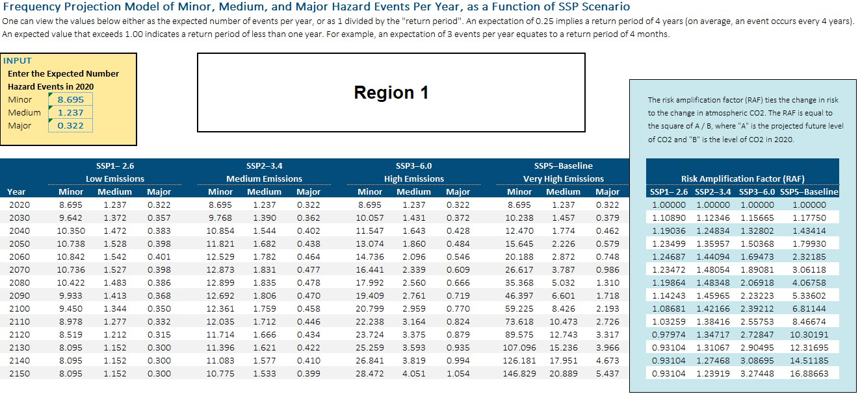

*Example of projected region 1 hazard frequency*

1. Calculate the projected property damage using the predicted frequencies and the average damage value for each hazard level.

## Appendix 3: Detailed calculation of the variables used in calculating economic costs



*Property value is divided into 13 ranges in the original dataset*

## Appendix 4: Economic costs comparison in the short term





## Appendix 5: Economic costs comparison in the long term





## Appendix 6: Projected displacement and incentive costs in the short term



## Appendix 7: Projected displacement and incentive costs in the long term



## Appendix 8: Projected Storslysia GDP

Using the projected inflation and one-year interest rate above, the GDP from 2021 to 2150, under the 2020-dollar value is calculated based on the below formula:

Then compute average GDP across 100 different simulated rate scenarios for each year.

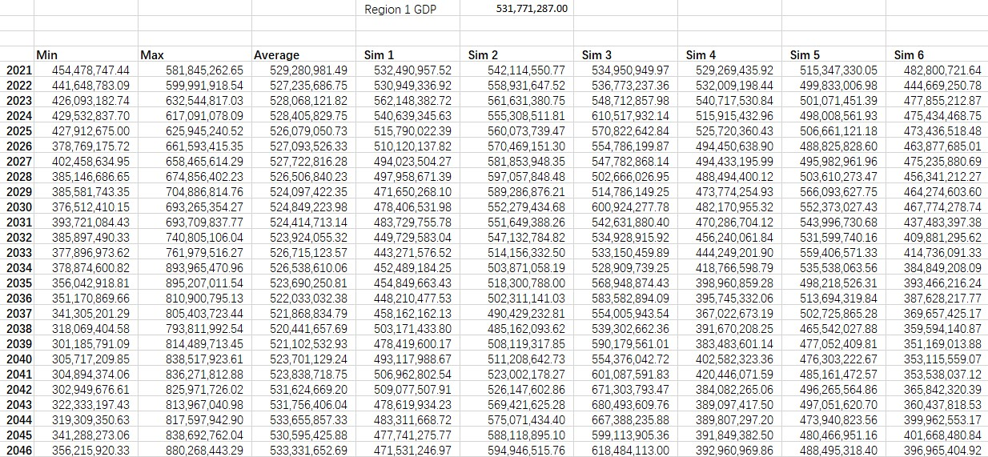

*Header of 130 years * 100 simulations on GDP according to the simulated rates.*

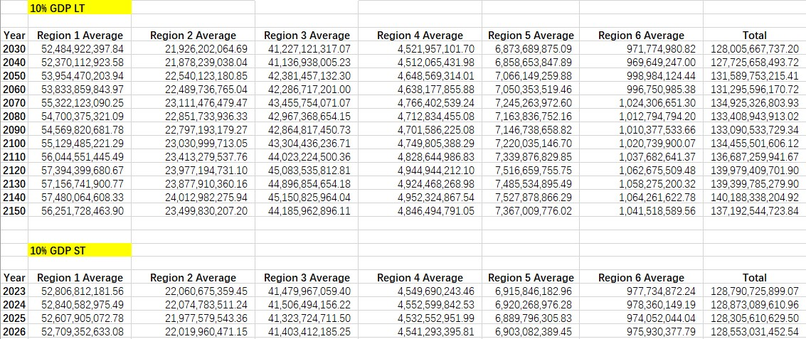

*10% GDP for comparison in both long- and short-term.*

## Appendix 9: 5 percentile and 95 percentiles of the historical property damage



## Appendix 10: Projected economic capital for the program



## Appendix 11: Detailed analysis of the benefit payment critical value

The critical values leading to indifference in costs between with and without program, under different SSP assumptions.

|  |  |  |  |  |
| --- | --- | --- | --- | --- |
| Incentives Ꝕ | SSP | Temporary relocation % | Replacing house goods | Labor & materials |
| 9185 | SSP1-2.6 | 0.8 | 0.4 | 0 |
| 14450 | SSP5-Basline | 1 | 0.75 | 0.5 |

The comparison of costs at the highest incentive. When the incentive exceeds 14400, the policy cost in 2030 will exceed the no-policy cost under SSP5-Baseline. For the other SSP cases, the future policy costs will be greater than the no-policy costs when the incentive is 14400.





The comparison of costs at the lowest incentive. When the incentive exceeds 9185, the policy cost in 2150 will exceed the no-policy cost under SSP1-2.6. For the same incentive, the policy cost in other SSP cases will be much lower than the no-policy cost.



